University: Chung Hua University

Total Area of Campus Buildings in CHU
Architecture and Design Building | Administration Building
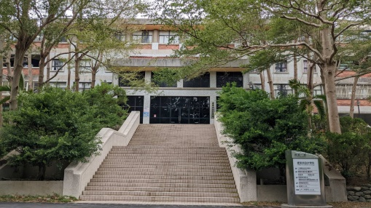 | 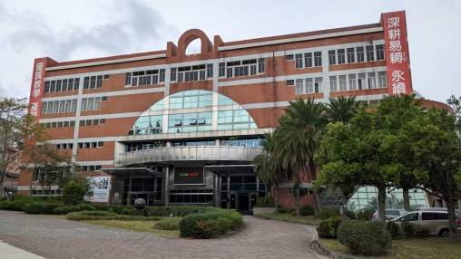
Area: 8,377 m2 | Area: 19,216 m2
Engineering Building I | Stadium
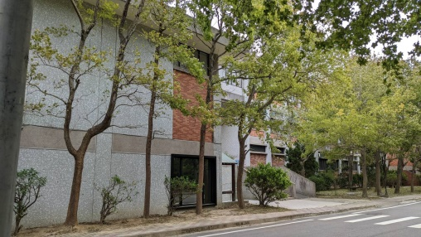 | 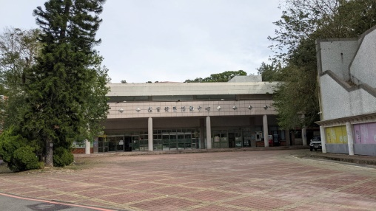
Area: 8,775 m2 | Area: 5,146 m2
Humanities and Social Sciences Building | Research and Development Building
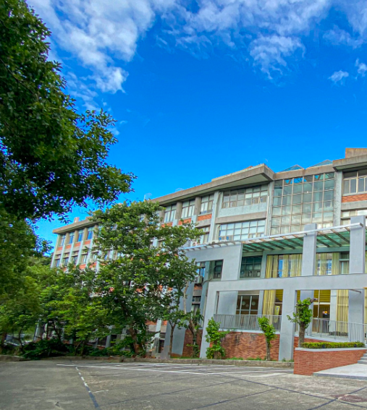 | 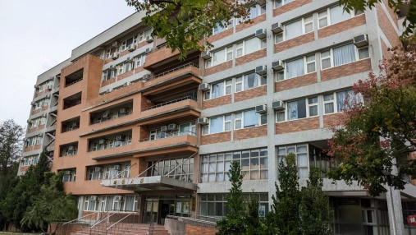
Area: 6,424 m2 | Area: 8,188 m2
Management Science Building | Engineering Building II
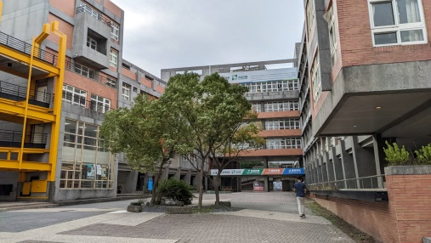 | 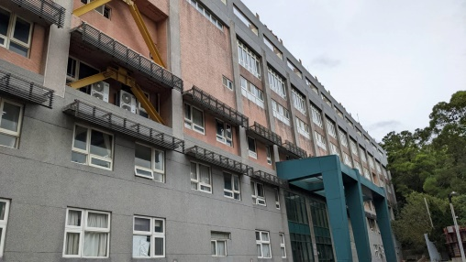
Area: 17,388 m2 | Area: 10,369 m2

Dormitory I | Dormitory II
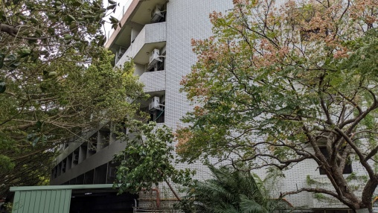 | 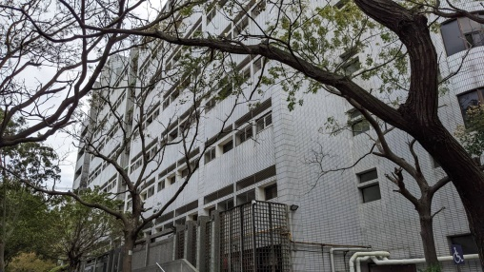
Area: 6,543 m2 | Area: 7,117 m2
Dormitory III | Dormitory IV
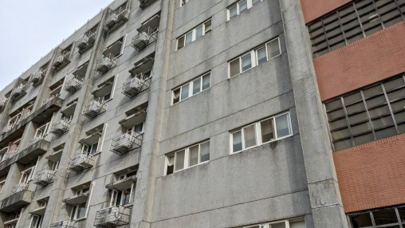 | 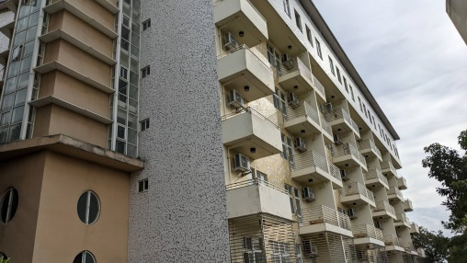
Area: 10,647 m2 | Area: 8,242 m2
Motorcycle Parking Tower
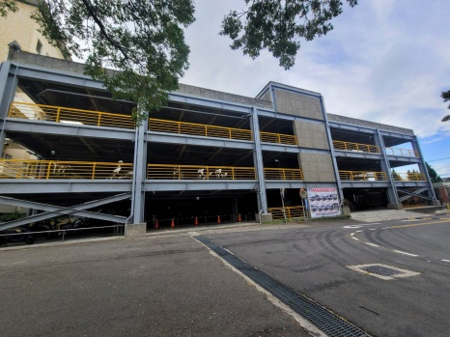
Area: 5,793 m2

Description:
Name of Building | Total Area
Architecture and Design Building | 8,377 m2
Administration Building | 19,216 m2
Engineering Building I | 8,775 m2
Stadium | 5,146 m2
Humanities and Social Sciences Building | 6,424 m2
Research and Development Building | 8,188 m2
Management Science Building | 17,388 m2
Engineering Building II | 10,369 m2
Dormitory I | 6,543 m2
Dormitory II | 7,117 m2
Dormitory III | 10,647 m2
Dormitory IV | 8,242 m2
Motorcycle Parking Tower | 5,793 m2
Total | 122,225 m2

